Reviewing Submitted Event Registration
Before You Start
- The Event Status must be “Active” for managers to be able to review and approve event registrations.

Steps  - 1. Click on the Events tab in the navigation pane.  - Click on the Submitted sub-tab.  - Click on the name of a record to begin the review process. | Screenshots  (Screen appearance may vary per state)  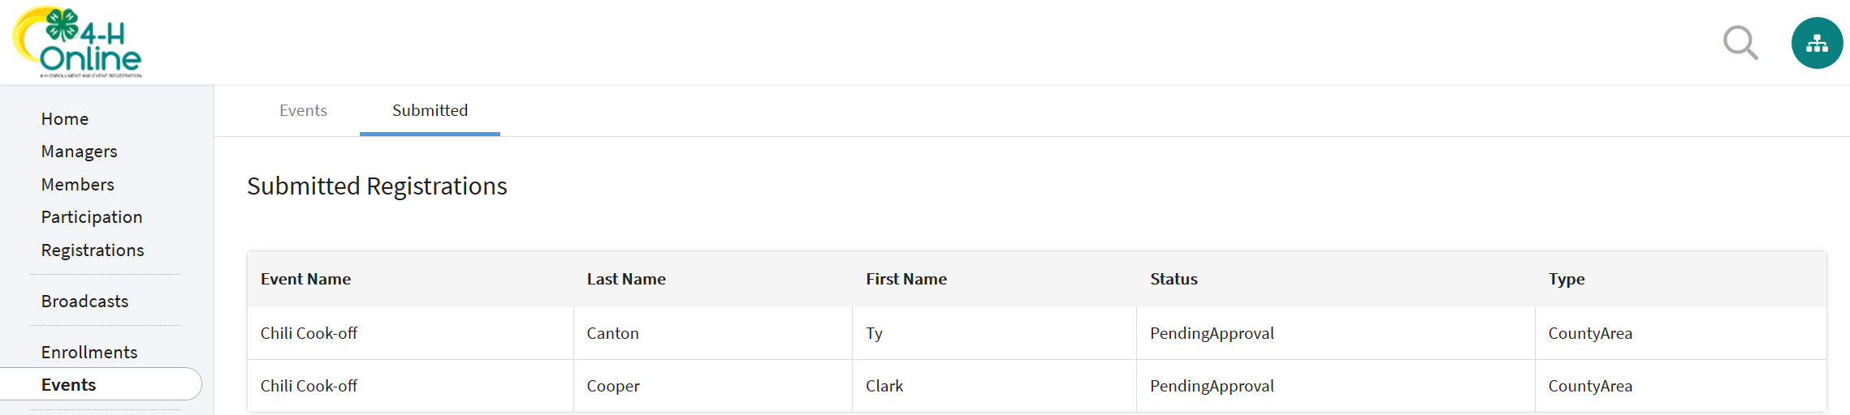
- Review the Registration Type Details, Other Questions, Health Form – Medical Release, Consents, and Invoice Information (if applicable).  - Managers may edit the Other Questions responses and the Invoice to apply a coupon if applicable.  - There are three options for processing the event registration:  - Approve – accept the registration.  - Send Back – enter comments and click Send Back to return the event registration to the member for corrections.  - Block – Rejects the registration and does not allow the member to register again. | 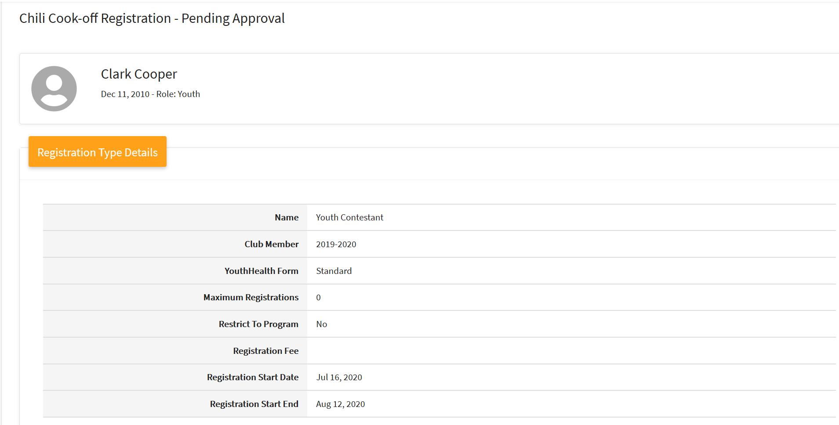  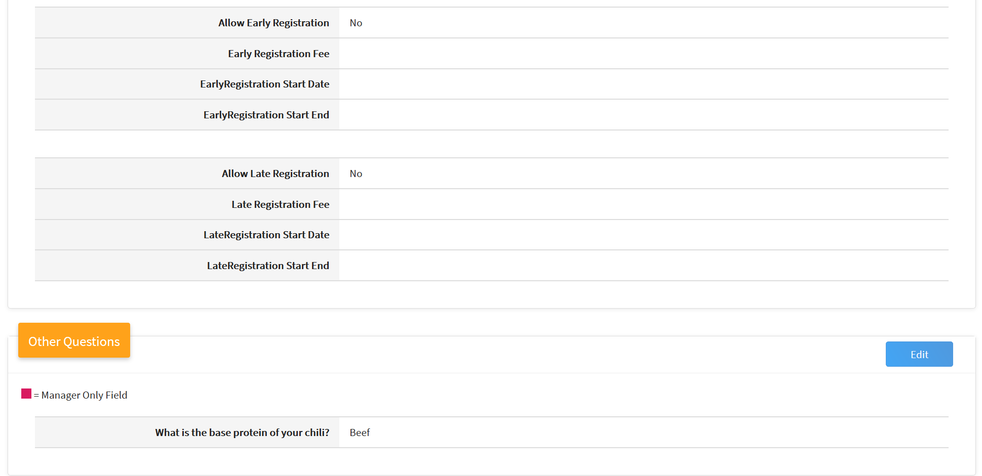  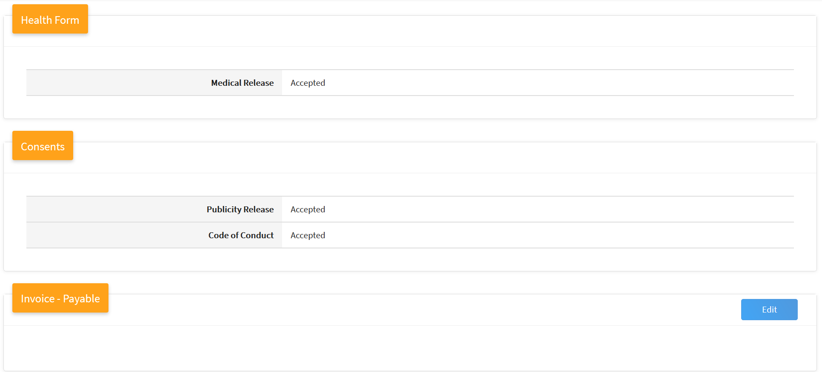  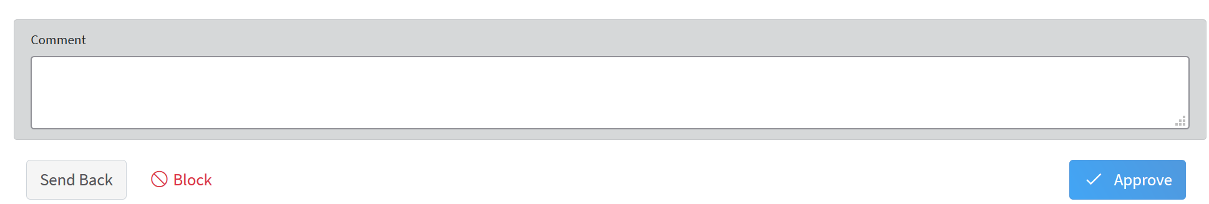
Tips
It is best to leave the event in active status until its conclusion except to make adjustments to the setup of the event, its registration types, and registration questions and file uploads.

